Creating x-y Table from Fit Curves
Fit Curves and Fit Sum are treated as function equations in MagicPlot Fit Plots. But in some cases (e. g. to export and plot fit data with other application) you may want to create (x, y) table with Fit Curves y-values. For this purpose use Project -> Create Table from Curves menu item when Fit Plot is active.
You can either add new Table to a Folder in current Project or export table to a text file.
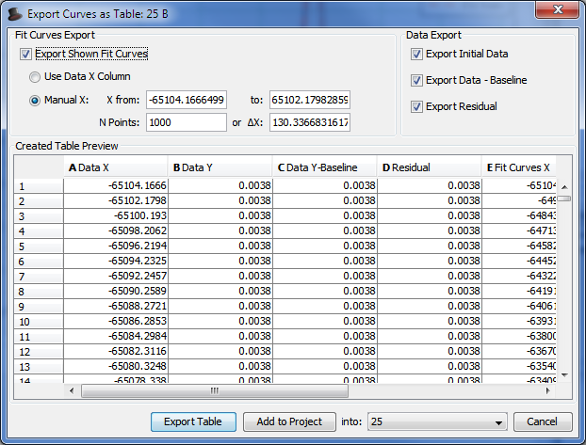Create Table from Curves window

