Table Editing
In MagicPlot Table is used to store numeric data. All tables use floating-point numbers in IEEE 754 double precision format.
Empty cells are equivalent to Not-a-Number values.

Table Context Menu
Many table editing functions are available in table context menu (right click to open).
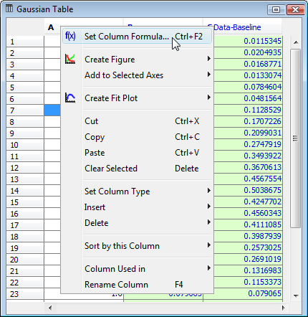Table context menu

Columns Numbers
Columns are enumerated starting with 1. The first 26 columns are additionally denoted with Latin letters: A, B, C, ... Y, Z, 27, 28, 29, .... You can use either numbers or letters, addressing cells and columns in formulas.

Moving (Reordering) Columns
Hold Alt key and drag column header to rearrange table columns. If Alt key is not pressed, mouse dragging on header will select the columns.

Editing Table
You can edit table cell by double click on it. You can either enter a number or an expression (e.g. writing pi in cell equals to 3.1416..., writing 1+2 equals to 3).
See Formula Syntax section for expression syntax.

See Also
- Formula Syntax
- Not-a-Number

