Setting Column Formula
Use Table -> Set Column Formula menu item to open column formula dialog window.
See formula syntax.
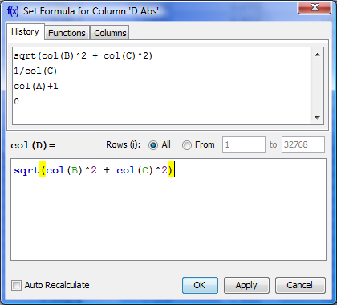 Set column formula dialog

Row Index
Variable i contains the current row index. Rows are enumerated from 1.

Rows Evaluation Order
Rows are always evaluated one after another from the first to the last in the specified range. Accordingly the row number i is incremented after each step.

Example
- You can use this behaviour to calculate factorial: set 1 in the first row of column A and after that set formula cell(A, i-1) * i and rows interval from 2 to 100. Note that formula is to be set for rows beginning from the second, and not from the first. You will get the factorial of row number (i).

Using Table Data
There are two functions to obtain current table cell values in formula:
- col(A) -- returns the value of cell in column 'A' in the current (i-th) row. Equivalent to cell(A, i).
- cell(A, 3) -- returns the value in column A and row 3.
You can use either upper-case letters (A...Z, e.g. col(B)) or numbers (1, 2, 3,.., e.g. col(1)) in columns numeration in arguments of col and cell functions.

Example
- col(A) + 15 + cell(B, i+1)

What is "Not-a-Number returned at row #" Warning?
Some mathematical functions can be defined only on a certain interval. For example, square root (sqrt(x)) is not defined for negative numbers (all calculations in MagicPlot are made in real numbers, not complex). Hence if the argument of sqrt is negative, a Not-a-Number (NaN) is returned. If a NaN value occurs in some part of formula, the result of calculation will also be a NaN, and corresponding table cells will be empty.
The calculations are not terminated if NaN value occurs in some row(s).
In some cases you may want to check if a NaN values occurs in calculations. MagicPlot shows the warning “Not-a-Number returned at row #”. This row number is the first row in which NaN value was returned. MagicPlot also highlights the function or operator which first produces NaN value.

See Also
- Formula syntax

