Introducing MagicPlot 2.7
- Full release notes
- Help contents
- List of features
- Download MagicPlot
This update is free for MagicPlot Pro 2.x users. Just download and run the new version.

Color Map Plots (in Pro edition only)
We are proud to introduce long-awaited color map plots support in MagicPlot with the following features:
- Non-uniform x/y data support
- Bicubic and bilinear image interpolation, available with non-uniform data also
- Fast rendering of large tables
- Discrete and smooth color interpolation options
- Zooming with mouse/touchpad
- Multiple color map plots and curves in one axes box
- Palette customization and saving of presets
- Transparent colors support
- Exporting compact images in vector formats
- Fully integrated in MagicPlot work flow (coping/pasting color map, zooming etc.)

Non-Uniform X/Y Data Support and Image Interpolation
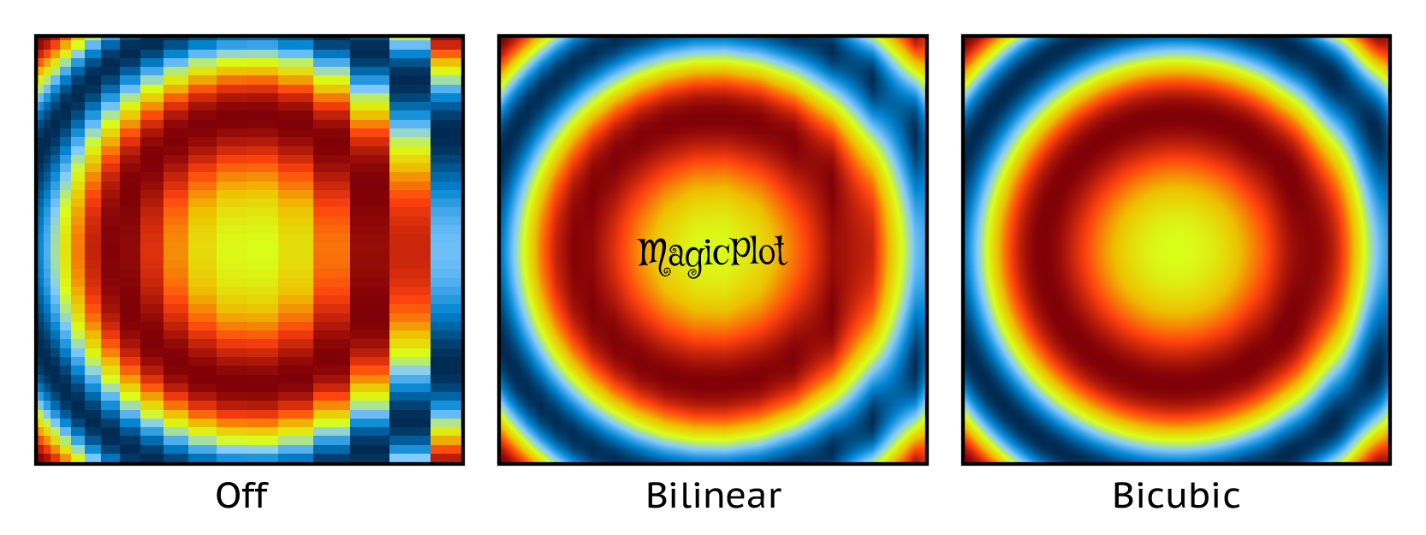

Image Interpolation

Fast rendering of large tables
Plot dragging and zooming with mouse is smooth even with table of size 1000×1000.

Color Interpolation Options
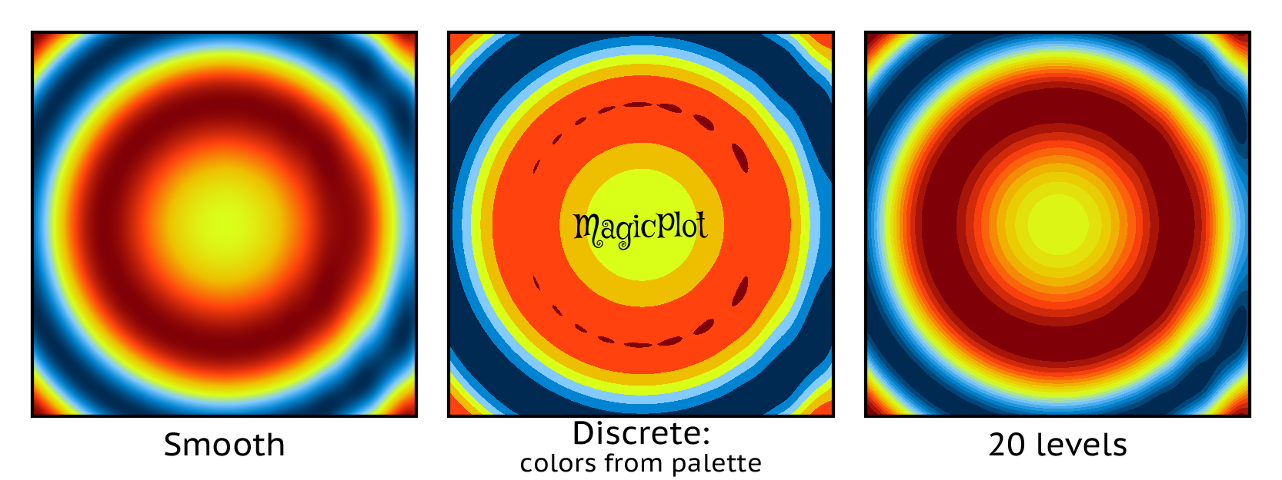
- Use exact color values from palette;
- Interpolate colors;
- Set number of equal color intervals.

Zooming with Mouse/Touchpad

Multiple Color Map Plots and Curves in One Axes Box

Palette Customization and Presets Saving
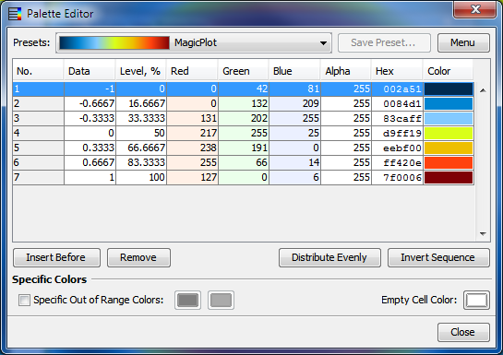

Transparent Colors Support

Compact Vector Image Export

Text Annotations and Drawing Tools in Student Edition
In freeware MagicPlot 2.7 Student edition text and drawing tools from Pro edition are now available.
Drawing tools buttons

Available tools are:
- Text
- Line
- Arrow
- Rectangle
- Ellipse
- Image insertion
- Dimensions toolbar

Various Improvements and Fixes
Many little enhancements and bug fixes were made based on user feedback and testing.

