Help topics on the Next MagicPlot Release
<span style="color:red"><b> These topics will be added to MagicPlot Help when next version is released. </b>
- In Joining the Parameters of Fit Curves - new topic from Nonlinear Curve Fitting: Fit Plot

Joining the Parameters of Fit Curves
In some cases you may want to fit the data with two Gauss or Lorentz peaks with the same width but different positions and amplitudes, for example. You can do this in two ways: by specifying custom Fit Curve with your equation or by joining the 'width' parameters of two peaks.
To join parameters of two or more Fit Curves select one of desired Fit Curves, then select desired parameter in parameters table and press Join button in the bottom of the panel (or double click on parameter).
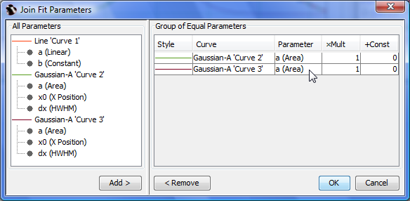Joining Fit Parameters
You can specify the selected parameters as equal or proportional by entering multiplier and constant for each parameter.
Joined parameters are shown with blue color (instead of black) in curve parameters table.
- In Importing Table from Text File (ASCII) new screenshot...
- In Creating a Copy of Table, Fit Plot, Folder or Figure new topic

Creating a Copy of Table, Fit Plot, Folder or Figure
You can create a full copy of selected project components (Tables, Fit Plots, Folders, Figures) by selecting Create a Copy item on context menu.
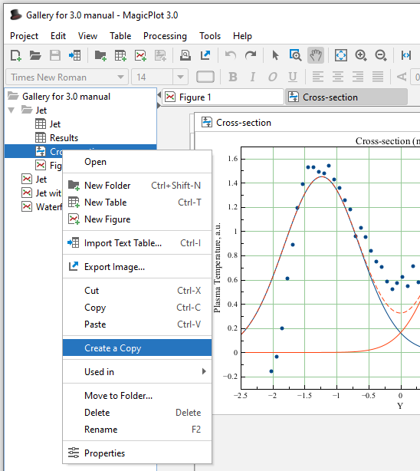Create a Copy Menu Item

Creating a Copy of Fit Plot or Figure
If the only Fit Plots and Figures are selected for creating a copy, the created Fit Plots and Figures will use data from the same tables as initial ones. If you select also the Tables which contain plotted data then the created Fit Plots and Figures will use data from created copies of Tables.
- In Nonlinear Curve Fitting: Fit Plot:
  - about changing curves order by dragging
  - about adjusting parameters with mouse wheel
  - fit has not converged, suspicious curve
- In Keyboard Shortcuts about infinity, columns rearranging on linux with Meta/Win key, Print/preview shortcut
- In Adding and Arranging Axes Boxes on a Figure new screenshot

MagicPlot 1.4, Major update, Feb 2011
- Added: Joint parameters can be proportional, not only equal
- Added: Reading and renaming table column names when importing tables from text files
- Added: Import tables from clipboard with import wizard
- Added: Setting the scale of selected axes in inspector toolbar
- Added: Creating a copy of Tables, Fit Plots and Figures
- Added: Curve selection, editing cure style in inspector panel without dialog opening
- Added: Cut, Copy and Paste curves between Fit Plots and Figures
- Added: Tab/Shift+Tab and arrow keys select next/previous curve on plot or figure
- Added: Changing Fit Curves order by dragging in curves table
- Added: Adjusting parameters with mouse wheel (with Ctrl pressed)
- Added: Help about inserting Greek letters and math symbols in shortcuts window
- Added: 'Colorize Selected' item in color button menu when multiple curves are selected
- Added: Parameters covariance matrix in Fit Report
- Improved: Correct processing of missing values and repeated column delimiter in imported text file with table
- Improved: Highlighting of suspicious curve (peak) if fit has not converged
- Improved: Text redrawing on Figures and Fit Plots was optimized: much faster redrawing of big texts
- Improved: New table is created in selected dataset in project tree if any
- Improved: Adding Figure components in Figure properties dialog: project tree view improved, double click support
- Improved: Using row number as X when adding table data to Figure, adding multiple data without closing dialog
- Improved: Setting y error column just in import wizard
- Improved: Image zoom “smoothed”
- Improved: Scale (linear/log10) type is now saved in Figure templates
- Improved: Adding data to Figure from multiple Tables (in Figure properties dialog): Column selection dialog is showed once for all Tables
- Improved: Continuous interval selection of legend labels (and curves) with Shift
- Improved: Fit stops after tho consecutive iterations (not one) which changes Chi square smaller than the minimum deviation decrement
- Improved: Coping and pasting tables: No more 'NaNs' in copied tables, empty rows are preserved when pasting
- Fixed: Table from Curves failed to add table to new folder, some tooltips were added
- Fixed: Inverted scale: log scale labels, scrolling, splitting fit intervals
- Fixed: Custom grid lines at 0 position
- Fixed: Scale scrollbars bounds did not account for Fit Curves after opening of Fit Plot
- Fixed: Multiple selected objects bringing to front and sending to back
- Fixed: Ctrl+Ins, Shift+Ins, Shift+Del shortcuts did not work with drawn objects and in text label editing
- Fixed: Marker types setting when adding multiple data to Figure
- Fixed: Issue on deleting table with Fit Plot data which is used on Figure
- Fixed: Incorrect numbers rounding when axes labels multiplier is not equal to 1
- Fixed: Fitting with joined parameters when not all joint curves are summed
- Fixed: Drawing error bars when showing fit residual
- Fixed: Columns rearranging on Linux with Win (Meta) key pressed
- Fixed: Critical issue with saving project files with “ (quotes) in some Figure legends
- Fixed: Legends format is some cases was not saved in project file
- Fixed: Joining parameters of one curve
- Fixed: Absence of error for formula a^-b in some cases. Now braces are always required: a^(-b)
- Fixed: Measuring distance with scale zoom tool: current axes selection was ignored
- Fixed: Undo of changing image size in some cases
- Fixed: Filling under spline-connected data curves
- Fixed: Critical issue: accounting for y errors from columns in fitting
- Fixed: Deleting table with deleted columns with evaluators
- Fixed: Undoing custom fit equation editing with illegal expression
- Many other little improvements and fixes

