Histogram Calculation (Pro edition only)
Open Table or Figure or Fit Plot with initial data and select Processing → Histogram menu item to calculate histogram.
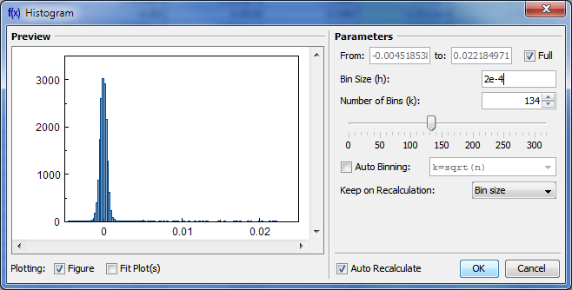Histogram creation dialog

Binning Options
You can either set the bin size/count manually or specify auto binning criteria.

Bin Bounds
MagicPlot align the the lower limit of the first bin exactly at the beginning of specified histogram range (From field). The upper limit of the last bin is calculated on the basis of the specified bin size and may be greater than the specified right histogram limit (to field) as shown on the screenshot above. Enter round value in the From field if you want the lower limit of the first bin to be round.

Auto Binning Criteria

You can enter custom criteria in ''Auto Binning'' combo box:
- Typing k=... means setting the number of bins k
- Typing h=... means setting the bin size h.

You can use these parameters in the expression:
- n --- the number of data points
- s --- data standard deviation
- m --- data mean
- min --- data minimum
- max --- data maximum.

The default alternatives are:
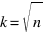
- --- Default criteria in Excel, Origin and some other software
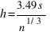
- --- Scott's formula
- --- Sturges' formula
- MISE optimisation --- Shimazaki method. MagicPlot finds the minimum of Mean Integrated Squared Error (MISE) for the number of bins from 2 to min(n/2, 20n1/2) where n is the number of data points. See this paper and site for details: Shimazaki and Shinomoto, Neural Comput 19 1503-1527, 2007, http://2000.jukuin.keio.ac.jp/shimazaki/res/histogram.html.

'Keep on Recalculation' Option
This option is used when the histogram is recalculated. Recalculation may be cause by input data change (if Auto Recalculate checkbox is selected) or invoked manually (Recalculate menu item in histogram table column context menu).

See Also
- Data Processing and Auto Recalculation

