Getting Started: Tables, Figures, Fit Plots and Undo
MagicPlot Projects contain Tables, Figures and Fit Plots. MagicPlot Project files have .mppz extension.
- Tables contain only numerical data.
- Tables which contain associated data are located in one Folder.
- Fit Plots are intended for non-linear curve fitting and subtracting baselines.
- Figures are intended to graphically represent multiple data.
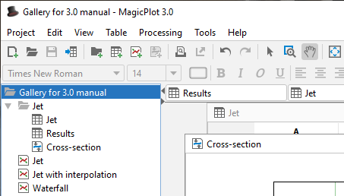Project tree
Typically, you need to open, edit, process, plot and fit multiple data acquired in various experiments or series of experiments within single project. Ordinarily you have the source (imported) Table and a number of Tables with derivative data, such as Fourier transform or statistics of source Table data. MagicPlot automatically creates a new Folder every time you import new Table. All derivative data is stored in the same Folder by default. All Plots created from Tables in certain Folder are stored in the same Folder.

Undo/Redo and History
MagicPlot supports unlimited depth undo/redo function with History dialog window. History dialog supports multiple undo and redo. Undone actions are marked light gray. Last saved state is set off in bold.
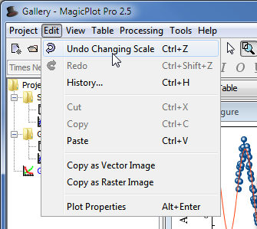Undo/Redo and History menu | 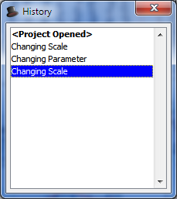History dialog

Where to start?
In most cases you may start with importing table from text file by clicking Project -> Import Text Table menu item.

Creating Figures and Fit Plots
The easiest way to create Figure or Fit Plot is the following:
- Select two columns (x and y) in Table containing your data
- Select Create Figure or Create Fit Plot item in the Table context menu
You may also use Create Figure or Create Fit Plot buttons in the toolbar.

Adding New Table to Existing Folder
You can add new table to existing folder by selecting New Table in Folder context menu.
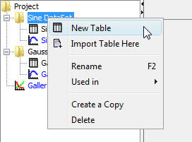Folder context menu

Enter Expressions in any Numeric Field
MagicPlot can evaluate simple expressions entered in any numeric text field (see formula syntax for details.) For example, you can enter 12/pi in circle width and height fields in Dimensions toolbar if you want its perimeter to be equal to 12 (remember that p=πd, where p is perimeter and d is diameter):
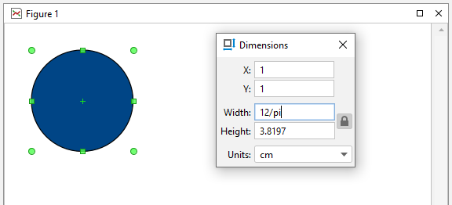All numeric fields support expressions

