Axes Style in Figure Properties
Axes style can be set in Figure Properties window (or Fit Plot Properties for Fit Plot). This window contains multiple tabs with axes drawing settings.
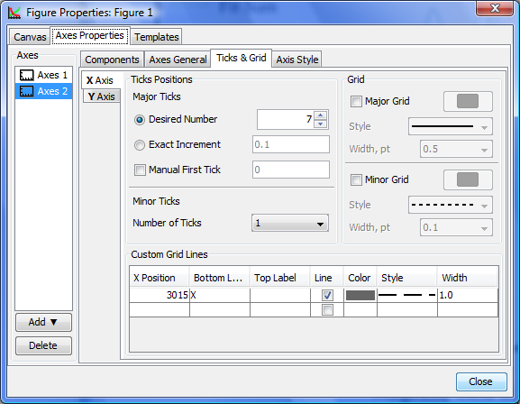Figure Properties window

