Drawing on Figures and Fit Plots, Canvas Zoom and Objects Selection
You can draw the following kinds of objects on Figures and Fit Plots (Pro edition only):
- Text labels with formatting support
- Lines
- Arrows
- Rectangles
- Ellipses
Select appropriate instrument in the right part of toolbar to draw an object.
The properties of selected objects can be changed in the inspector toolbar (the second line of toolbar).

Canvas Zooming (Pro edition only)
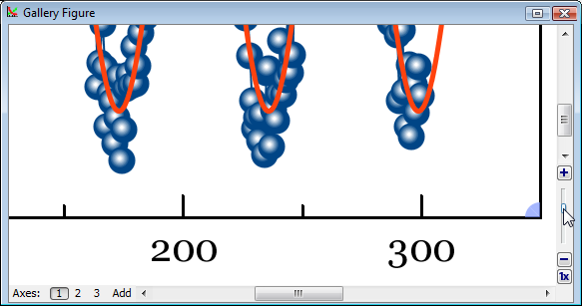Canvas zoom slider and buttons
If you need to precisely draw some little objects you can zoom in the canvas using slider in right bottom (Pro only). The button 1x fits the canvas to the window.
Do not confuse the canvas zooming in and changing the X/Y scale.

Objects selection
Every object on Canvas can be selected by clicking on its border or inside it. Hold Ctrl key (Windows, Linux) or Shift key (Mac OS) to add another object to current selection.

Moving an Object Forward or Backward
When objects overlap, you can change the order of objects drawing. Use Bring to Front and Send to Back items in object context menu (right click on it to open).
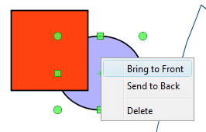Ellipse context menu

Snapping to Other Objects
When you drag an object or change its size MagicPlot will try to snap the bounds of this object to other objects. While snapping MagicPlot shows you a red ruler and an object to which the bounds are snapping. If you do not want to align your objects this way, hold Ctrl key to disable snapping.

