MagicPlot Calculator
MagicPlot Calculator is a useful formula calculator built in MagicPlot. To open calculator use Tools -> Calculator menu item.

Using calculator outside MagicPlot
Calculator window stays on top when MagicPlot main window is minimized to task bar (Dock on Mac), so you can use the Calculator when working with other applications.
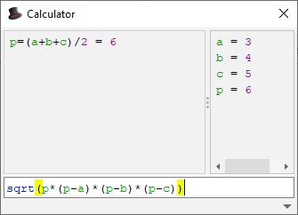Heron's formula in MagicPlot Calculator

Using the Calculator
- Type expression like (12+4)*sin(pi/2) and press Enter to get the result
- Type a=5 to set variable a to 5
- Use Up/Down keys to recall previously entered expressions
- Use ans variable or press Ctrl+Up to insert the result of latest operation
- Standard functions and variables (sin, cos, pi, e, etc.) are supported
MagicPlot Calculator uses the same formula as other formula fields in MagicPlot application.

See Also
- Expression Syntax

