Creating Transparent Figures and Fit Plots
To create an image with transparent background open Figure Properties or Fit Plot Properties dialog window and set Transparent Background radio button in Canvas tab.
The background of transparent Figures and Fit Plots is shown with a grey-and-white chequerboard. If you are preparing a picture for a dark background you can change the colour of chequerboard to dark grey by selecting View -> Transparency Checkerboard in main menu.
In case of transparent background you can set the preview background colour in Image Preview window.
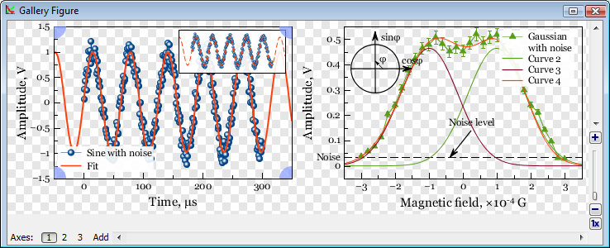Transparent figure example

See Also
- Colours and Opacity Adjustment

