Table Editing
In MagicPlot Tables are used to store numeric or text data depending on column type (numeric/text).

Data Types
MagicPlot supports these data types in Tables:
Format | Description
Numeric | 64-bit double precision floating-point numbers (IEEE 754)
Text | Unicode string with unlimited length
Notes:
- Data type is set for entire columns. One column may not contain data with different type.
- Empty cells are equivalent to Not-a-Number values.
- Values from text columns are treated as empty cells if used as numbers.

Table Context Menu
Many table editing functions are available in table context menu (right click to open).
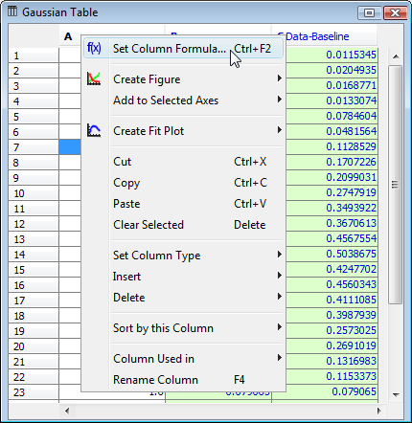Table context menu

Changing Column Type
Use Set Column Type menu in column context menu to change column type (numeric/text).

Columns Numbers
Columns are enumerated starting with 1. The first 26 columns are additionally denoted with Latin letters: A, B, C, ... Y, Z, 27, 28, 29, .... You can use either numbers or letters, addressing cells and columns in formulas.

Renaming Columns
Double click on column header to rename table column. You can also use Rename Column context menu item or press F4.

Moving (Reordering) Columns
Hold Alt key (Option on Mac, Meta/Win on Unix-like) and drag column header to rearrange table columns. If Alt key is not pressed, mouse dragging on header will select the columns.

Editing Table
You can edit table cell by double clicking on it. You can enter either a number or an expression (e.g. typing pi in a cell results in 3.1416..., typing 1+2 results in 3).
See Formula Syntax section for expression syntax.

Displaying Column Formulas in Table
MagicPlot marks columns for which formulas or other evaluators (FFT, integral, etc.) are set with blue header color. You can see the formula in column header tool tip.
The columns which are auto recalculated are not editable and have green background instead of white.
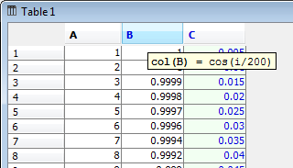Table header highlighting
On the screenshot above:
- Column A has no formula
- Column B has a formula, auto recalculation is off
- Column C has a formula, auto recalculation is on, so this column is not editable

Fit Column Widths
To fit the width of one column, double click on right separator line in table header. To fit several selected columns widths, double click on one of column separators in table header.

See Also
- Setting Column Formula
- formula
- Table Sorting
- Missing Values (NaN) in Tables and Calculations

