Screenshots

Click on image to enlarge.

MagicPlot Pro 1.3 on Mac OS X
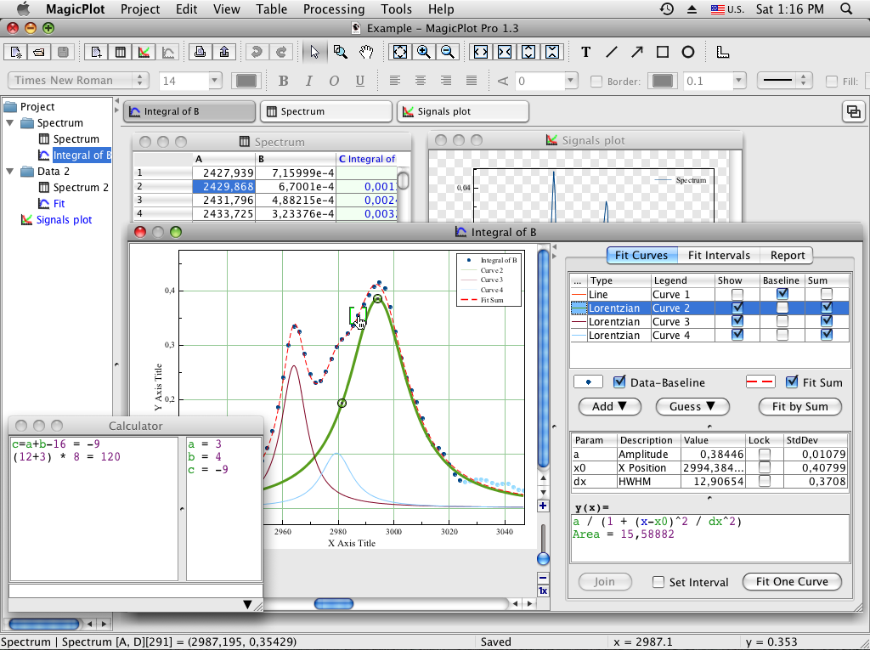

MagicPlot Pro 1.3 on Ubuntu 10
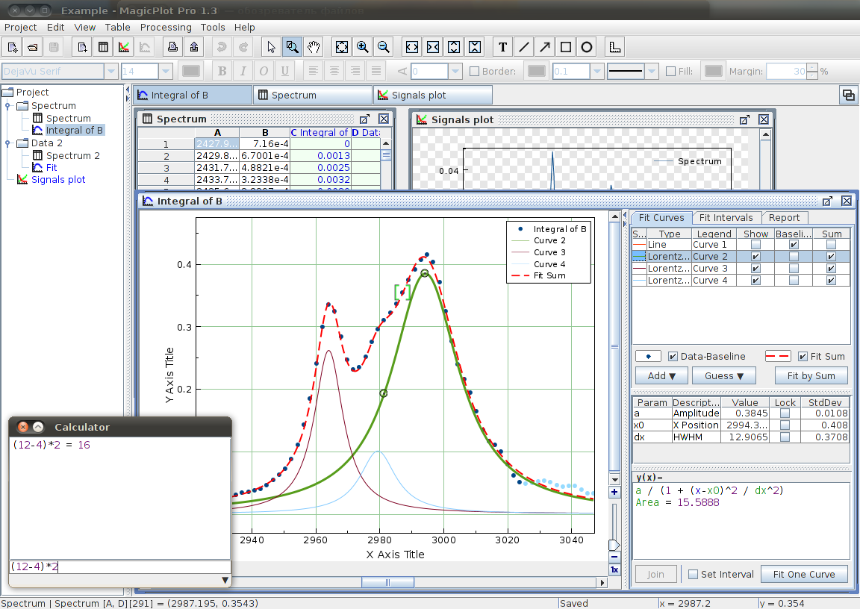

MagicPlot Pro 1.2 on Windows Vista
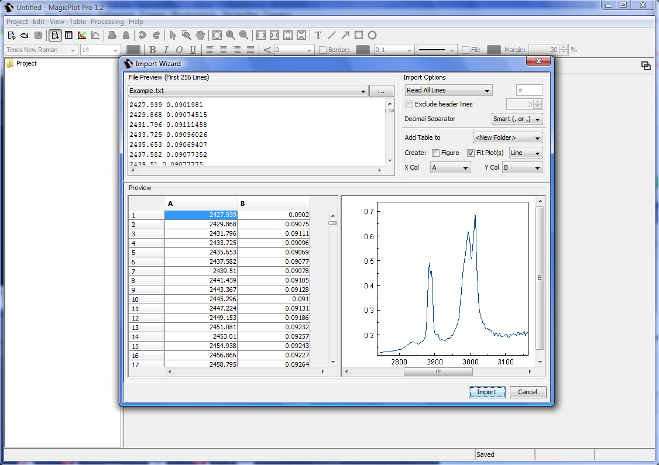Import Table from Text File
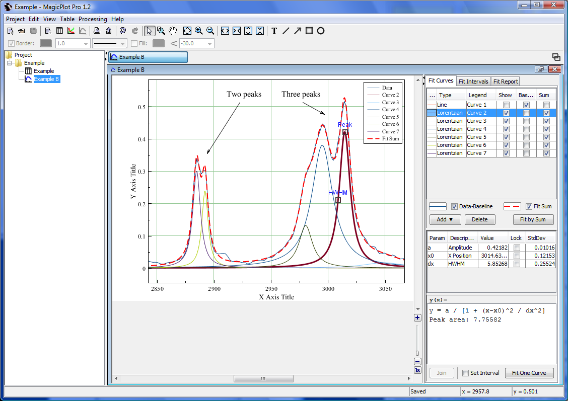Nonlinear Fit
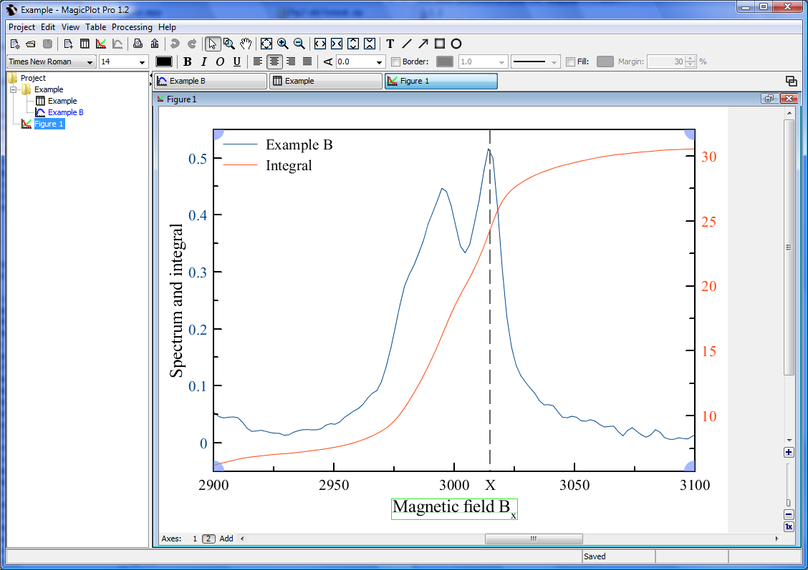Figure Example
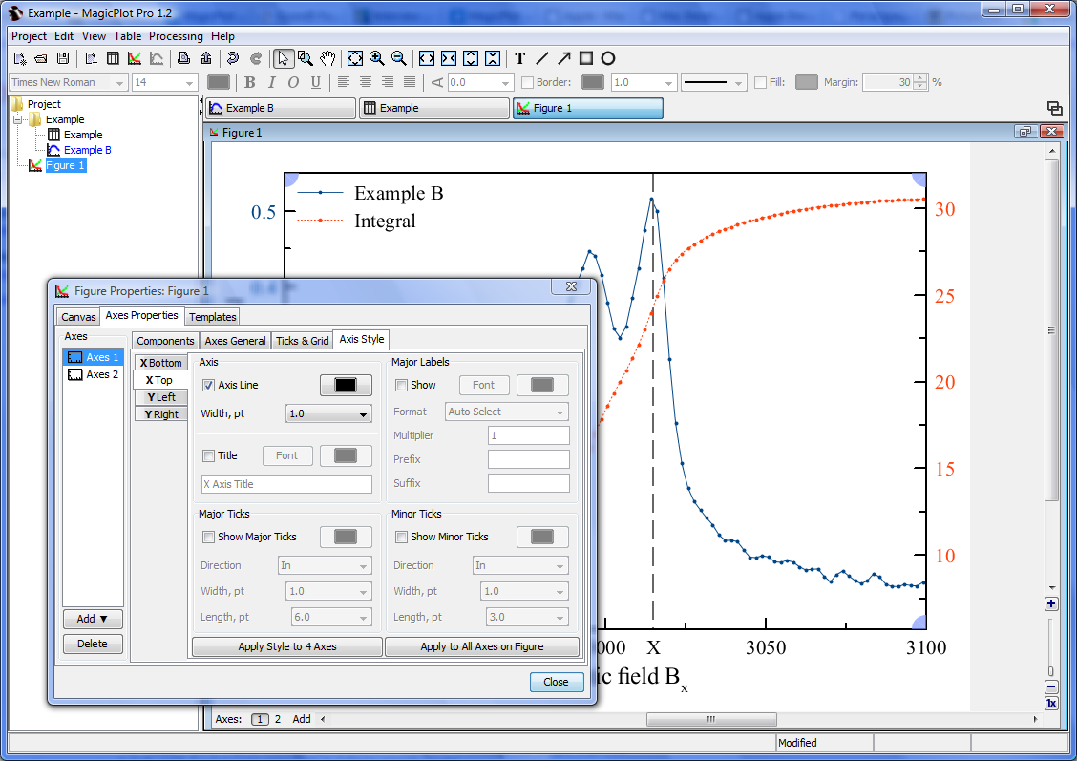Figure Axis Properties
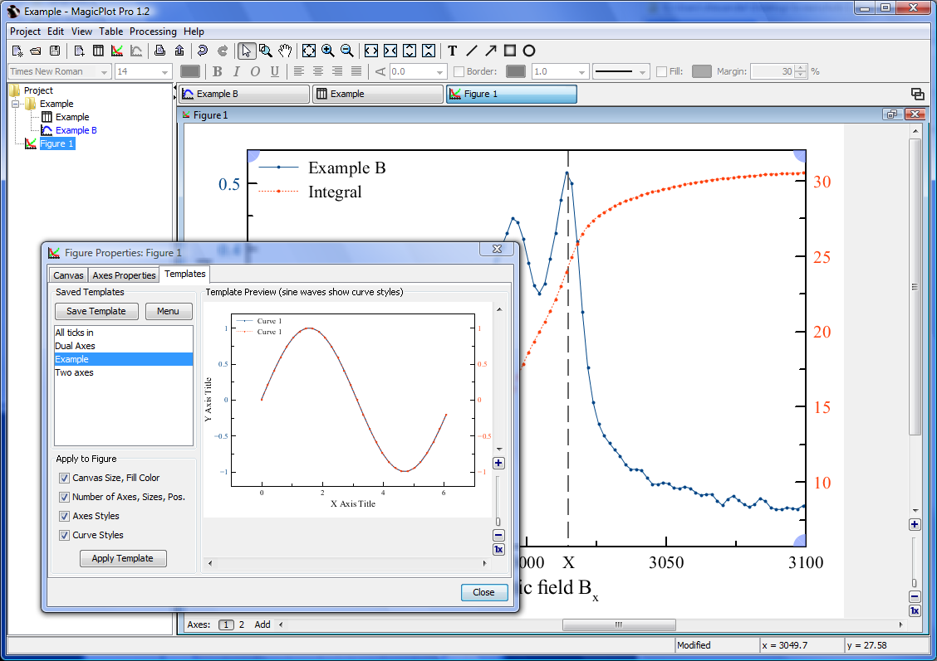Figure Templates
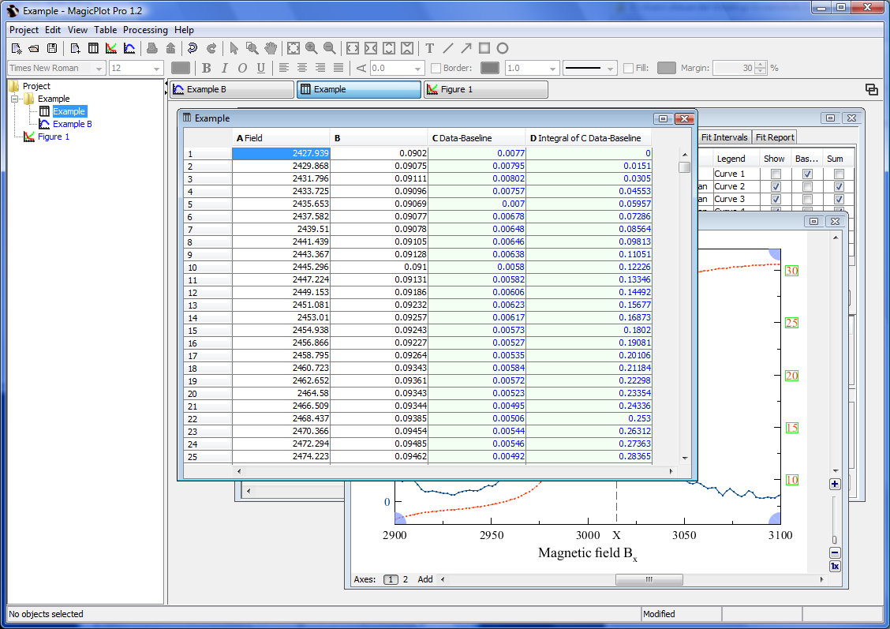Table

