Introducing MagicPlot 2.7
- Full release notes
- Help contents
- List of features
This update is free for MagicPlot Pro 2.x users. Just download and run the new version.
Download MagicPlot

Color Map Plots (in Pro edition only)
We are proud to introduce the long-awaited color map plots support in MagicPlot with the following features:
- Non-uniform x/y data support
- Bicubic and bilinear image interpolation, available with non-uniform data also
- Fast rendering of large tables (>1000×1000)
- Discrete and smooth color interpolation options
- Zooming with mouse/touchpad
- Multiple color map plots and curves in one axes box
- Palette customization and saving of presets
- Transparent colors support
- Exporting compact images in vector formats
- Fully integrated in MagicPlot work flow (coping/pasting color map, zooming etc.)
See also: Manual topic on Color Map Plots.

Non-Uniform X/Y Data Support and Image Interpolation
MagicPlot offers 3 image interpolation options:
- Off (nearest neighbor);
- Bilinear;
- Bicubic.
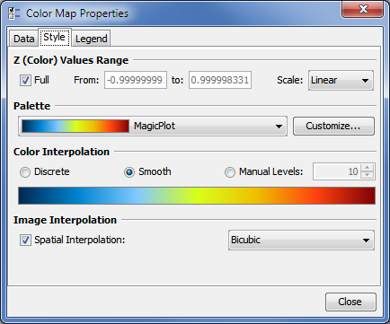Color Map Style tab
MagicPlot supports non-uniform X/Y data and interpolation is available for non-uniform data also:
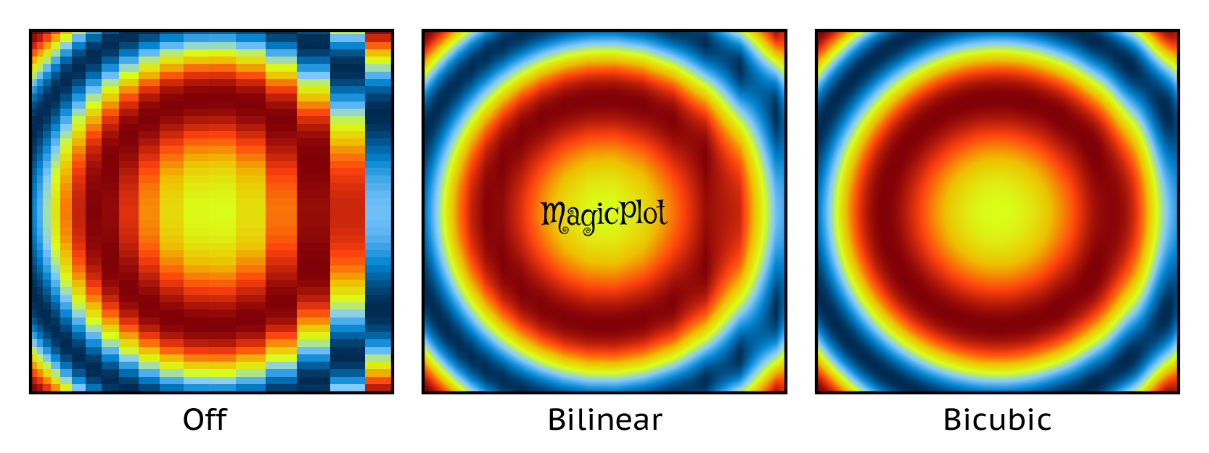
This image in PDF: spatial-interpolation-demo.pdf

Color Interpolation Options
MagicPlot offers 3 color interpolation options:
- Use exact color values from palette;
- Interpolate colors;
- Set the number of equal color intervals.
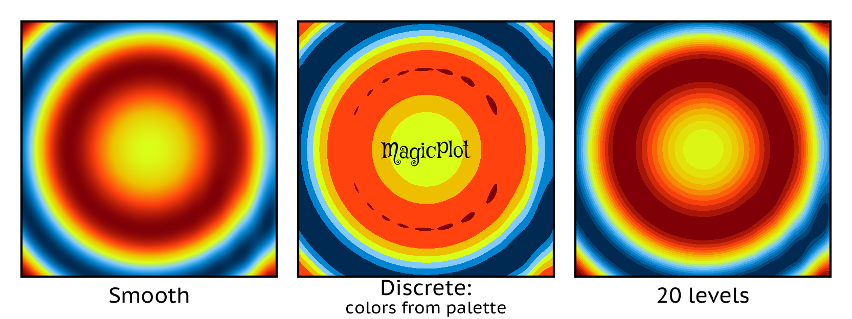
This image in PDF: color-interpolation-demo.pdf

Zooming with Mouse/Touchpad
All the standard MagicPlot navigation tools are available:
- Zooming in by selecting a region;
- Dragging with 'Hand' tool, right mouse button works with other tools;
- Mouse wheel vertical scrolling, horizontal scrolling with Shift;
- Ctrl+scroll -- vertical scale adjustment;
- Ctrl+Shift+scroll -- horizontal scale adjustment;
- Left mouse button + scroll -- proportional scaling.
<iframe width="420" height="315" src="https://www.youtube.com/embed/tqNZxFm_7kI" frameborder="0" allowfullscreen></iframe>

Fast rendering of large tables
Plot dragging and zooming with mouse is smooth even with table of size 1000×1000.

Palette Customization and Presets Saving
MagicPlot supports saving of color map palette presets. These presets are stored in .mppc files.
See also: Additional Color Map Palettes.
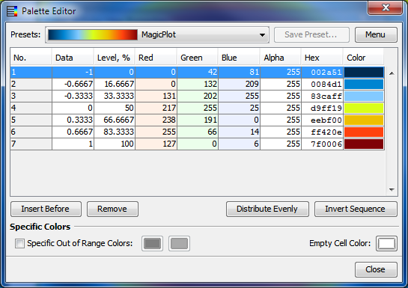

Text Annotations and Drawing Tools in Student Edition
In the freeware MagicPlot 2.7 Student edition text and drawing tools from the Pro edition are now available.
Drawing tools buttons

Available tools are:
- Text
- Line
- Arrow
- Rectangle
- Ellipse
- Image insertion
- Dimensions toolbar

Various Improvements and Fixes
Many little enhancements and bug fixes were made based on the user feedback and testing. The full list can be found in release notes.
Download MagicPlot

