Introducing MagicPlot 1.5
MagicPlot 1.5 is capable of opening multiple projects in one running instance of application and also adds more processing features.

See Also
- Download MagicPlot
- Full release notes
- Help contents
- List of features

☞ Opening Multiple Projects in One Instance of Application

Now you can work with multiple projects without launching multiple instances of application. The 'New Project' and 'Open Project' commands don't ask about closing current project now.
- Each project is opened in separate window
- Grouping MagicPlot windows in Windows 7 task bar
- Less memory usage
- Importing text tables to the opened project
- '-silent' option for import files with previous settings

☞ Sorting and Transposing Tables (Pro only)

Sorting by multiple columns is also supported.
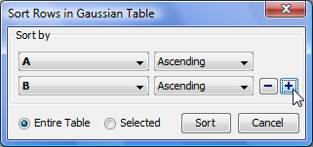

☞ Descriptive Statistics Toolbar (Pro only)

This new window shows the statistics on selected columns, row or curves. You can select which statistical properties to show.
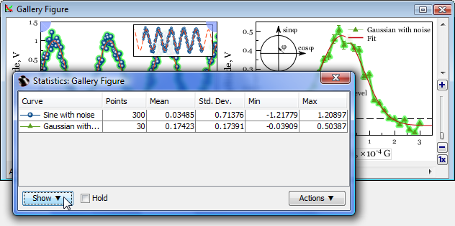
- Column statistics functions were also added to Column Formula Dialog.

☞ Histograms (Pro only)

Histogram options dialog with preview.
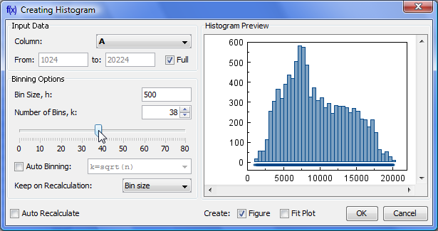

☞ Quick Plot Tool (Pro only)

This window allows visualizing of table data without creating Figure of Fit Plot.
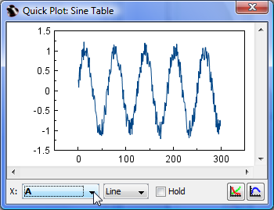

☞ Other Enhancements
- Highlighting text labels and invisible components on mouse over
- Exporting multiple images and tables from project tree context menu, expand/collapse all menu item in Project context menu
- Fullscreen mode
- Axes scale and titles can be applied from Figure template
- Some bugs were fixed

Investigate with pleasure!
- Get MagicPlot now!

