Help topics on the Next MagicPlot Release
<span style="color:red"><b> These topics will be added to MagicPlot Help when next version is released. </b>
- In Joining the Parameters of Fit Curves - new topic from Nonlinear Curve Fitting: Fit Plot
- In Importing Table from Text File (ASCII) new screenshot...
- In Creating a Copy of Table, Fit Plot, Folder or Figure new topic

Creating a Copy of Table, Fit Plot, Folder or Figure
You can create a full copy of selected project components (Tables, Fit Plots, Folders, Figures) by selecting Create a Copy item on context menu.
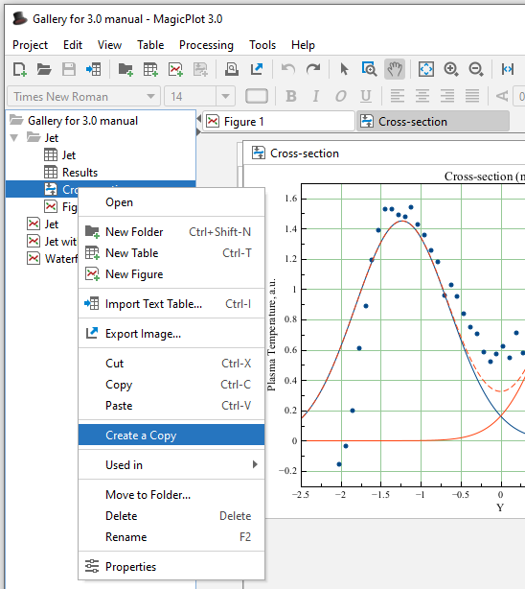Create a Copy Menu Item

Creating a Copy of Fit Plot or Figure
If the only Fit Plots and Figures are selected for creating a copy, the created Fit Plots and Figures will use data from the same tables as initial ones. If you select also the Tables which contain plotted data then the created Fit Plots and Figures will use data from created copies of Tables.
- In Nonlinear Curve Fitting: Fit Plot:
  - about changing curves order by dragging
  - about adjusting parameters with mouse wheel
  - fit has not converged, suspicious curve
- In Keyboard Shortcuts about infinity, columns rearranging on linux with Meta/Win key, Print/preview shortcut
- In Adding and Arranging Axes Boxes on a Figure new screenshot

