Integration
Open Table or Figure or Fit Plot with initial data and select Processing -> Integrate menu item.
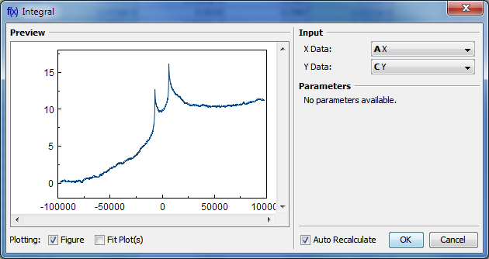

Baseline Correction
If your initial data to be integrated contains a baseline (usually constant or linear), you may want to subtract it from data before integrating. (A constant baseline will result in linearly growing integral.)
In such case the algorithm may be the following:
- Create Fit Plot with your initial table data
- Add a Fit Curve which simulates the baseline. You may specify a custom equation
- Specify Fit Interval so that it contains only noise points
- Fit the data by clicking Fit Sum button
- Subtract the baseline fitting curve from data by checking Baseline checkbox in curves list
- Use menu Processing → Integrate to integrate the plotted data without baseline.

Algorithm
To perform integration you should specify two columns: x and y. Missing values are ignored.
MagicPlot uses trapezoidal rule to compute the integral:
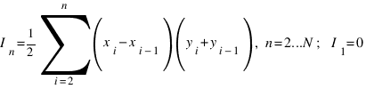

See Also
- Data Processing and Auto Recalculation
- Differentiation

