Guessing Peaks (Pro edition only)
MagicPlot can approximately locate peaks in spectrum. To locate peaks click on Guess button in Fit Curves tab of Fit Plot. Peak guessing is performed by looking for local minimums of second derivative of data-baseline.
When Guess Peaks window is open you can see the preview of guessed peaks on Fit Plot. This preview is updated every time you change the parameters in the window.
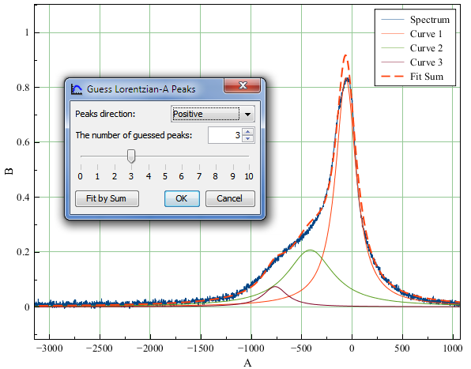Guess peaks dialog

Smoothing of Data and 2nd Derivative
Smoothing is used in order to filter narrow peaks which can be guessed from noise. MagicPlot peak guess tool is capable of smoothing both data and second derivative before finding local minimums. Smoothing is used only to find peaks and does not affect the data on Fit Plot.
Savitzky–Golay method is used for smoothing. This algorithm performs a local polynomial regression of specified degree on specified number of points. The more points, the smoother is curve.

The Number of Peaks
MagicPlot sorts found peaks by amplitude and suggests only a specified number of greatest peaks. You can change the number of guessed peaks with slider or by entering value in the text field with spinner.

See Also
- Nonlinear Curve Fitting: Fit Plot
- Specifying Custom Fit Equation
- Using Spline for Baseline Subtraction
- Predefined Fit Curves Equations

