Nonlinear Curve Fitting: Fit Plot
Nonlinear least squares data fitting can be performed using Fit Plot. To create a Fit Plot, select x and y columns in table, then select Table -> Create Fit Plot in main menu, or use context menu in table, or use Create Fit Plot button in the toolbar.
'Nonlinear' means here that analytical fitting function depends nonlinearly on varying parameters (fit parameters). Linear fitting is a quite simple method, which is based on solving the system of linear equations. Unlike linear fitting, nonlinear fitting is performed by iterative algorithm which needs the user to set the initial values of fit parameters.
To fit the data, implement these steps:
- Create a Fit Plot, specify y weighting in Plot properties, if any
- Specify fit function by adding Fit Curves
- Specify initial values of fit parameters (drag curves or enter accurate values)
- Specify used x data interval
- Run fitting
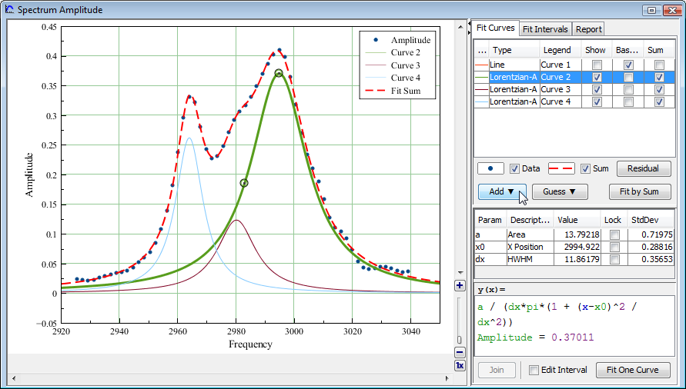Fit example

Further reading
This manual does not completely cover the complex nonlinear fitting methodology. We recommend you to take a look at this book:
- H. Motulsky and A. Christopoulos, Fitting Models to Biological Data Using Linear and Nonlinear Regression: A Practical Guide to Curve Fitting. 2003, GraphPad Software Inc., San Diego CA, graphpad.com. PDF is available here.

Fit Function is a Sum of Fit Curves
MagicPlot considers fit function as a sum of Fit Curves. Ordinarily in peaks fitting each Fit Curve corresponds to one peak in experimental data. There is a number of predefined Fit Curves (Line, Parabola, Gauss, Lorentz, etc.) You can also specify a custom Fit Curve. Baseline fitting components may be added to the fitting sum, too.
Fit Plot window contains the list of Fit Curves. Each Fit Curve in the list has three checkboxes: Show, Baseline, Sum:
- Show: Specifies whether to show this Fit Curve on plot. Active only if Baseline checkbox is not set
- Baseline: Toggles the subtracting of this Fit Curve from experimental data. You also can use Residual button to subtract Fit Sum from data
- Sum: Specifies whether to use this Fit Curve in sum fit function
Below the Fit Curves list is a parameters table which shows names, values, and descriptions of parameters relating to selected Fit Curve.

Copying Fit Curves from One Fit Plot to Another
You can copy and paste Fit Curves in curves table as usual. Use context menu in curves table or press Ctrl+C, Ctrl+V on PC and Cmd C, Cmd V on Mac (curves table must have focus, not the plot itself). MagicPlot copies Fit Curves parameters values, baseline/sum/show checkbox values and style.

Setting Initial Values of Parameters
Nonlinear fitting assumes that certain initial values of parameters are set before fitting. This procedure is very easy if you use predefined Fit Curves: you can drag curves on plot.
Initial parameters values for each Fit Curve can also be set in parameter table.

Parameter Locking
You can lock parameter(s) to prevent varying this parameter during fit and to prevent its changing due to setting initial values by mouse dragging (for built-in functions). Set the checkbox in Lock column in parameters list.

Fit Intervals
You can set the x intervals of the data. Data points outside these intervals are not used to compute the minimizing residual sum of squares (see below). You can use this feature if some data points (especially in the beginning or the end) are inaccurate, e.g. noisy.
Select Fit Interval tab to set intervals visually or edit accurate borders values:
- Double click on interval to split it
- Drag the interval border to move it. If intervals intersect, they will be merged
- Use context menu on the plot to create, delete and split intervals
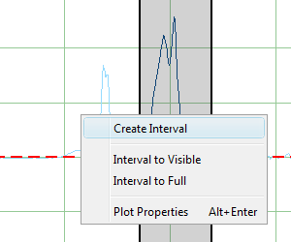Interval context menu | 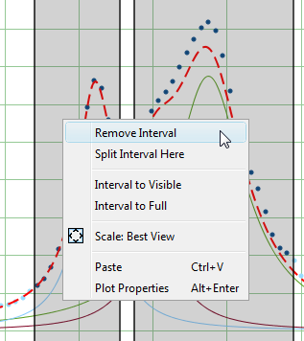Interval context menu

Baseline Fitting and Extraction
Fit Interval is also usable when baseline fitting. Before baseline fitting you can specify the interval which does not contain any signal points and contains baseline only. Set Baseline checkboxes at baseline Fit Curves after baseline fitting to subtract baseline from data. Then specify the whole interval and fit the data.
The most appropriate curve type for baseline fitting is spline.
Note that if you execute one of data processing algorithms (integration, FFT, etc.) on Fit Plot, then the difference between the data and baseline curves (which you do see on the plot) will be processed. You can use this behaviour to exclude baseline from data before integrating, see Integration for more information.

'Data-Baseline' Table Column
The 'Data-Baseline' column is appended to the Table with initial (x, y) fit data when you create Fit Plot. The 'Data-Baseline' column contains the difference between initial y data and baseline approximation (the sum of Fit Curves for which Baseline checkbox is set).
It is 'Data-Baseline' column that is actually plotted on Fit Plot.
Use 'Data-Baseline' column in Table if you want to process the data without baseline. This column is also used as initial data if you use Processing menu when Fit Plot is active.

Viewing the Difference between Data and Fit Sum Function (Residual)
MagicPlot offers two different ways to view the difference between data and Fit Sum function:
- You can set Baseline checkboxes for all fit function components to subtract them from data and explore the residual plot
or
- You can press and hold Residual button. The difference between data and Fit Sum function is shown while button is pressed. You can use either mouse or space key (if button is selected) to hold Residual button.

Fit One Curve
You can also use MagicPlot to fit the data with single selected Fit Curve by pressing Fit One Curve button. In this case a specific data interval for each Fit Curve is used and the main fitting data interval (set in Fit Interval tab) is ignored. Select Set Interval checkbox in the bottom of the Fit Plot panel to set specific fit intervals for each Fit Curve.
Because of using individual data interval this method is useful for baseline fitting. In order to fit baseline specify the intervals which does not contain signal (peaks) and contain only noise.

Joining the Parameters of Fit Curves
In some cases you may want to fit the data with two Gauss or Lorentz peaks with the same width but different positions and amplitudes, for example. You can do this in two ways: by specifying custom Fit Curve with your equation or by joining the 'width' parameters of two peaks.
To join parameters of two or more Fit Curves select one of desired Fit Curves, select desired parameter in parameters table and press Join button. Add parameters which will be joint in the opened dialog window. Joined parameters are treated as one fit parameter.
Joined parameters are shown with blue color (instead of black) in parameters table.

Fitting Algorithm
MagicPlot uses iterative Levenberg–Marquardt nonlinear least squares curve fitting algorithm which is widely used in most software.
Fit procedure iteratively varies the parameters βk of fit function f(x, β1, ..., βp) to minimize the residual sum of squares (RSS, χ2):
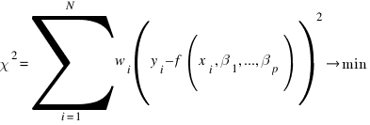
here:
- xi and yi are the data points,
- N is total number of points,
- f(x, β1,...,βp) is the fit function which depends on value of x and fit parameters βk,
- p is the number of fit parameters βk,
- wi are normalized y data weighting coefficients for each point yi:
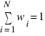
Calculation of the new guess of parameters on each fit iteration is based on the fit function partial derivatives for current values of fit parameters and for each x value:
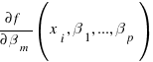
To start minimization, you have to provide an initial guess for the parameters.

Fit Procedure Stop Criteria
After each iteration except the first MagicPlot evaluates deviation decrement D:
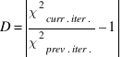
Deviation decrement shows how the residual sum of squares (RSS) on current iteration relatively differs from that on the previous iteration.
The iterative fit procedure stops on one of two conditions:
- If the deviation decrement D is less than minimum allowable deviation decrement, which is 10-9 by default
or (and)
- If the number of iterations exceeds maximum number of iterations, which is 100 by default
You can change the minimum allowable deviation decrement and maximum number of iterations in Fitting tab of MagicPlot Preferences.

Fit Progress Window
MagicPlot indicates fit process with a special window. Fitting curves are periodically updated on plot while fitting so you can see how fit converges.
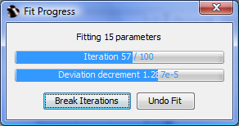Fit progress window
MagicPlot shows current iteration number and deviation decrement with two progress bars while fit is performed. The fit process stops when one of these progress bars reaches the end.
You can see two buttons on fit progress window:
- Break Iterations: Breaks iterations after current iteration. Use this button if you suspect that further iterations will not change the result.
- Undo Fit: Breaks iterations and reverts fit parameters to their initial (before fit) values. Use this button if you see that fit process converges to wrong result; change initial values of parameters and run fit again.

Weighting of y data
MagicPlot can use weighting of y values based on y errors si:
- If standard y errors are not specified: all wi=1
- If standard y errors si are specified:
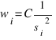
here C is normalizing coefficient (to make the sum of wi be equal to one):
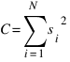
In Fit Plot Properties dialog (Plot Data tab) you can set one of the following methods to evaluate standard y errors si:
- Get y errors from table column(s),
- Percent of data for every point,
- Fixed value or Standard deviation --- do not use in weighting because in this case the error values are the same for all data points.

Undoing Fit
You can undo fit and undo changing initial parameters as usual using Undo function. It is a handy feature when experimenting with different models and initial parameters (e.g. peaks positions).

Formulas
In the table below you can find the formulas which MagicPlot uses to calculate fit parameters and values in Fit Report tab.
Because of some confusion in the names of the parameters in different sources (books and software), we also give many different names of same parameter in note column.
Parameter Name | Symbol | Formula | Note
Original Data and Fit Model Properties
Number of used data points |  | --- | This is the number of data points inside specified Fit Interval.
Fit parameters | β1,...,βp | --- | For peak-like functions (Gauss, Lorentz) these parameters are amplitude, position and half width at half maximum.
Number of fit function parameters β |  | --- | This is the total number of parameters of all fit curves which are summarized to fit.
Degrees of freedom
Estimated mean of data |  | 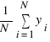
Estimated variance of data |  | 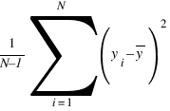 | Not used by fit algorithm, only for comparison.
Data total sum of squares, TSS | TSS | 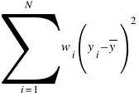 | TSS is also called sum of squares about the mean and acronym SST is also used.
Fit Result
Residual sum of squares, RSS |  | 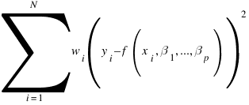 | This value is minimized during the fit to find the optimal fit function parameters.  RSS is also called the sum of squared residuals (SSR), the error sum of squares (ESS), the sum of squares due to error (SSE).
Reduced χ2 | 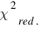 | 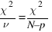 | The advantage of the reduced chi-squared is that it already normalizes for the number of data points and model (fit function) complexity.  Reduced χ2 is also called mean square error (MSE) or the residual mean square.
Residual Standard Deviation | s | 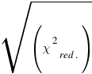 | Standard deviation is also called root mean square of the error (Root MSE)
Coefficient of determination |  | 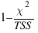 | R2 will be equal to one if fit is perfect, and to zero otherwise. This is a biased estimate of the population R2, and will never decrease if additional fit parameters (fit curves) are added, even if they are irrelevant.
Adjusted R2 |  | 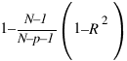 | Adjusted R2 (or degrees of freedom adjusted R-square) is a slightly modified version of R2, designed to penalize for the excess number of fit parameters (fit curves) which do not add to the explanatory power of the regression. This statistic is always smaller than R2, can decrease as you add new fit curves, and even be negative for poorly fitting models
Covariance Matrix of Parameters βk |  | 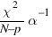 | 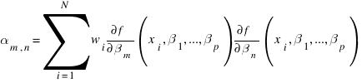  Here α is the matrix of partial derivatives of fit function with respect to parameters βm and βn which is used for fitting:
Standard Deviation of Parameters βk,  std. dev. |  | 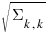
Correlation Matrix of Parameters βk |  | 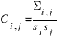

See Also
- Specifying Custom Fit Equation
- Using Spline for Baseline Subtraction
- Guessing Peaks
- Predefined Fit Curves Equations
- transform_xy
- Calculating Integrals and Statistics on Intervals using Fit Plot

