Using of Dimensions Toolbar
This toolbar is intended for precise setting of the position and size of one or more selected drawn objects on Figure or Fit Plot.
You can open Drawing Dimensions toolbar by selecting Tools -> Drawing Dimensions in main menu. Dimensions toolbar may be left opened.
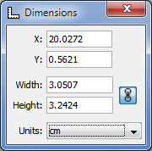Drawing Dimensions toolbar
Drawing Dimensions toolbar shows the coordinates and size of currently selected object(s). You can also specify the coordinates or size of several components.
- The x value is measured from the left edge of the canvas.
- The y value is measured from the top edge of the canvas.
- For rectangle or ellipse the specified coordinates determine the position of the upper-left corner.
- For text label:
  - x determines the left edge, center or right edge of text according to text alignment of label.
  - y determines the baseline position of the first line.
- For line or arrow the specified coordinates determine the position of the beginning.

