Colors and Adjusting Opacity
In MagicPlot you can set the opacity of each object (curve, text label, rectangle, etc.) to make them semi-transparent. Opacity is treated as a property of object color. You can set opacity in Opacity sub-menu in color pop-up menu which opens by clicking on color button.
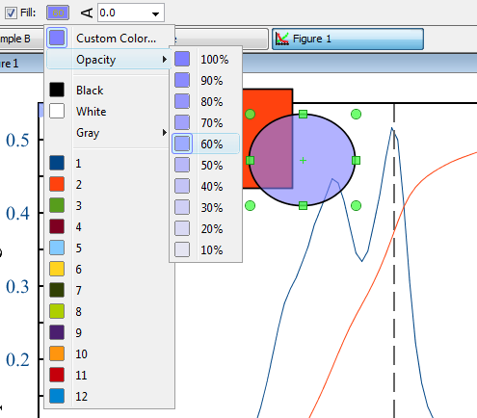Color pop-up menu

See Also
- Creating Transparent Figures and Fit Plots

